**Blankets made for you**

The Rich Task Project has allowed me to make a blanket out of recycled fabrics, taking my time to sew each, cut up piece of sheet together and using old sheets and batting from old quilts. I have made a blanket from old sheets cut up to make the front and then an old sheet from our cupboard and batting from my grandmother’s old quilt that was falling apart.

I have created this blanket as I we had so many old sheets in our cupboards that were sitting in their for years without use, so I decided that instead of throwing them out and creating more landfill I chose to make a blanket to create awareness to people that anything old did not have to go to waste and that we need to start to learn how to reuse and recycle.

This is useful to society as it shows people how to reuse and recycle items that they might throw out like old, worn clothes and old sheets with stains or holes in them. It helps society as once I informed people about what I was doing; they realized that they themselves could do it and help make a difference.

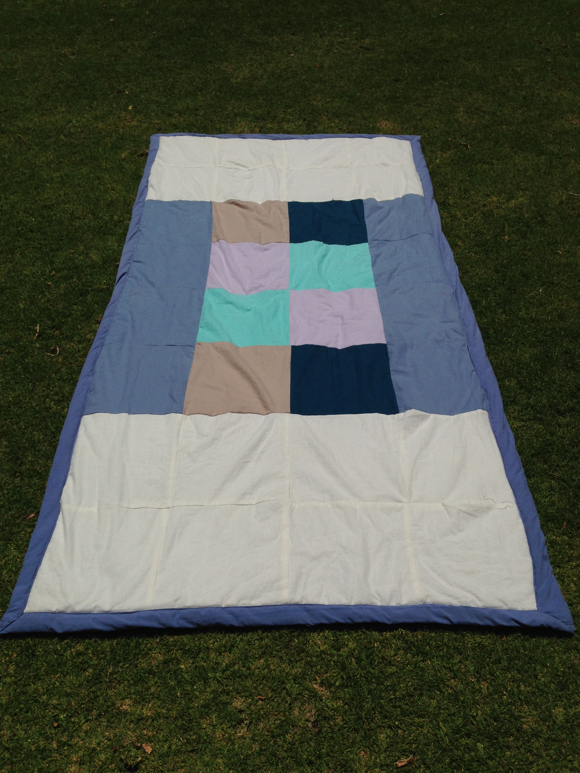My products relationship with sustainability, could be more sustainable as I made it with a sewing machine which used electricity but other than that my product is made of all recycled products they are not bio degradable, but what I have made is better than throwing them out. Others in the community could see what I have done and implement it in their everyday life by making their own blankets and using them or handing them out as gifts.

The challenges I faced during this project were learning again and sewing the entire quilt together. Also time management, working on my worksheets and working on my blanket took a long time to work out my design, and how I was going to sew it all together. The hardest thing for me working on my worksheets quickly and without distractions but I ended up getting them all done in the first couple of days which was good.

It took me about one week to complete my quilt, cutting, measuring and sewing.

I really enjoyed making this blanket as it really showed me how many non-biodegradable things we throw out and that results in masses of landfill, and the waste of natural resources gone to make sheets and blankets, that we could save on them and save the earth. The thing that inspired me to make a blanket is looking at all of the homeless people on the streets s without a blanket, food or shelter and the fact that other people have a home, food and clothes or sheets that they don’t use/wear anymore and aren’t good to recycle as second hand goods, are able to cut & restore parts of these items we don’t wear them any more when we could be making something good for the environment and people in need.